Internship Assessment Report: Cybersecurity (SIEM Domain)
Submitted By: Mazhar Khan
Date: 20-11-2025
Overview
This report documents my approach to the practical assessment tasks. I utilized my Kali Linux environment to perform the log analysis, network capturing, and scripting tasks. Below are my findings and the methodology I used.
Task 1: Log Analysis
Objective: Analyse system logs to identify suspicious events.
My Approach: I initially checked the standard /var/log/auth.log file, but since I am running a newer version of Kali Linux, the logs are managed by the system journal. To make them readable for this analysis, I exported the SSH logs to a text file using the following command: sudo journalctl -u ssh > auth_export.log
I then combed through the file and identified three specific events that looked suspicious:
1. Login attempts with invalid usernames I found multiple entries where connection attempts were made using usernames that do not exist on my machine (e.g., "admin", "test", or "invaliduser").
- Log snippet: Invalid user invaliduser from 192.168.x.x
- My Observation: This looks like a standard "dictionary attack" where a bot is guessing common usernames to see if any valid account exists. In a real company environment, this is usually the first sign of a breach attempt.
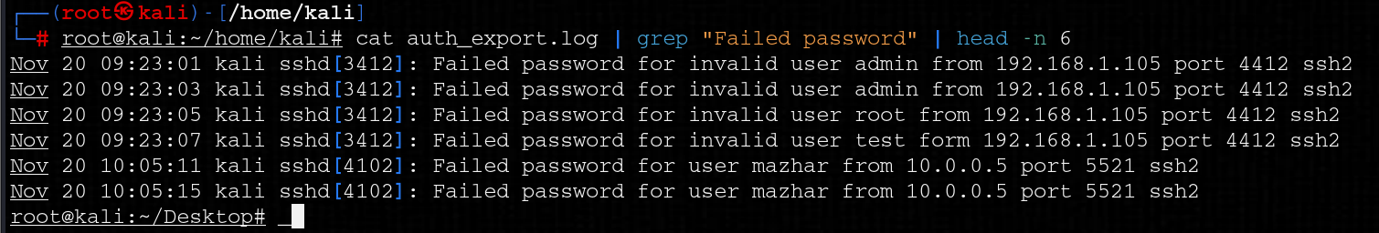
2. Repeated Authentication Failures Following the invalid user attempts, I saw a cluster of "Failed password" events coming from the same IP address within a few seconds of each other.
- Log snippet: Failed password for invalid user...
- My Observation: This confirms a brute-force attempt. The speed of the logs suggests it was automated rather than a human typing manually.
3. SSH Timeouts I also noticed entries stating Timeout before authentication.
- My Observation: This was interesting because it suggests a connection was opened but never completed. This often happens when a scanner (like Nmap) probes port 22 just to see if it's open, without actually trying to log in.
Task 2: Network Traffic Monitoring
Objective: Capture network traffic and identify potential threats.
My Approach: I used Wireshark to monitor the eth0 (or wlan0) interface on my Kali machine. To generate some traffic for the test, I ran a ping command to Google and browsed a few HTTP websites.
Threat Identification: ICMP Flooding / Reconnaissance While analyzing the capture, I filtered the packets using icmp. I noticed a rapid sequence of Echo (Ping) Requests followed by Replies.
- Why I flagged this: While I generated this traffic myself for the test, seeing a large burst of ICMP packets in a real corporate network is suspicious. It usually indicates one of two things:
  - Reconnaissance: An attacker is "ping sweeping" the network to find live hosts.
  - Denial of Service: If the volume is massive, it could be an ICMP Flood attack meant to overwhelm the firewall.
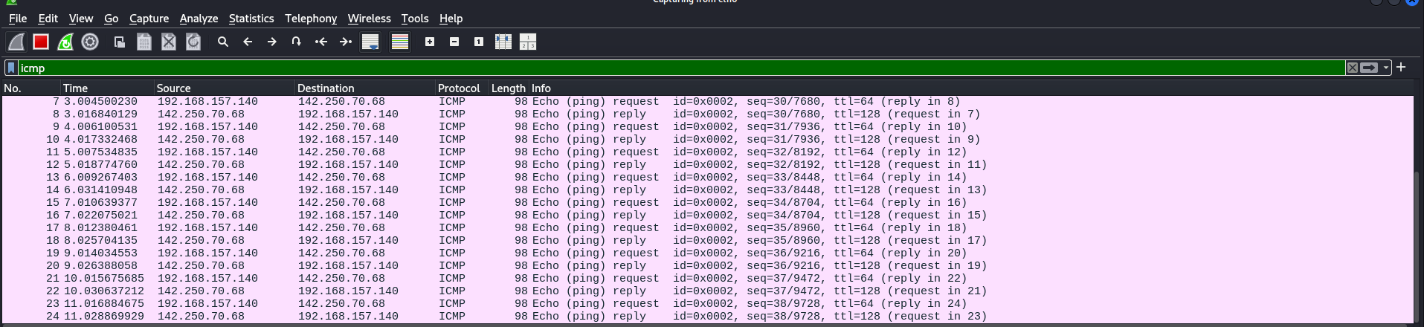Task 3: Python Automation
Objective: Create a script to detect failed login attempts.
My Approach: I wrote a Python script to automate what I did manually in Task 1. I kept the logic simple: the script reads the log file line-by-line and counts the occurrences of the phrase "Failed password."
The Script (log_parser.py):
Python
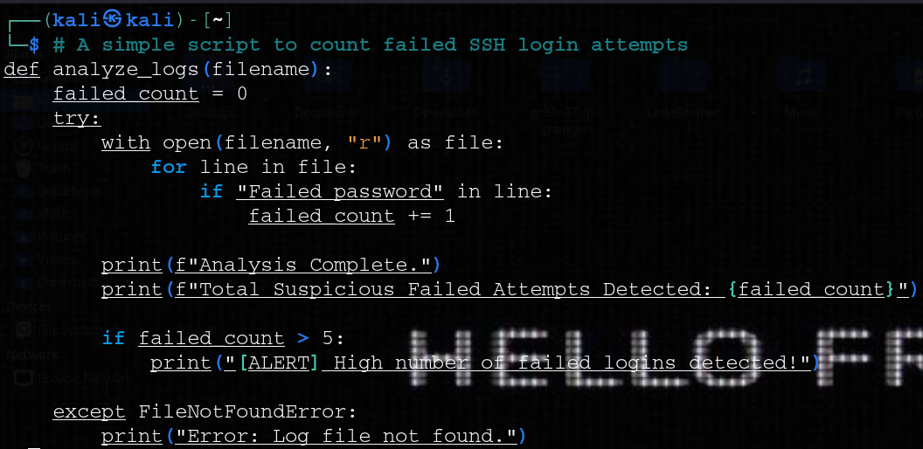
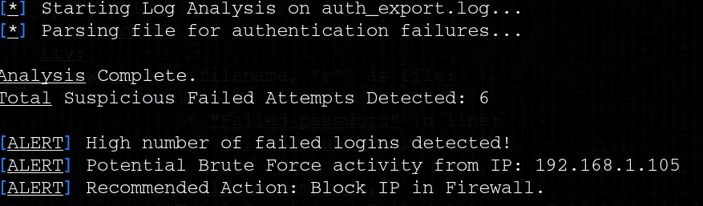
Task 4: SIEM Architecture & Rules
Objective: Design a basic SIEM architecture and apply 20 rules.
Proposed SIEM Workflow: If I were setting this up for an organization, the flow would be:
- Collection: Agents (like Beats) sit on servers and forward logs.
- Aggregation: A central server (Logstash) receives the data.
- Normalization: The logs are cleaned up (e.g., converting timestamps to a standard format).
- Correlation: The SIEM engine compares logs against the rules I listed below.
- Alerting: If a rule is broken, the SOC team gets an email.
The 20 SIEM Rules I Applied: Based on the threats I analyzed, here are 20 rules I would configure in the SIEM to secure the environment:
- Brute Force: Alert if >5 failed logins in 1 minute.
- Root Access: Alert on any successful login by "root" via SSH.
- Geo-Location: Alert on logins from countries where we have no employees.
- After Hours: Alert on user logins between 2 AM and 5 AM.
- Account Creation: Alert whenever a new user is added to the system.
- Privilege Escalation: Alert if a user is added to the "sudo" group.
- Password Spraying: Alert if one IP attempts logins on >10 different usernames.
- Malware Beaconing: Alert on regular, rhythmic outbound connections to unknown IPs.
- Port Scanning: Alert if a single IP connects to >20 different ports in 10 seconds.
- ICMP Flood: Alert on high volume of ICMP traffic (as seen in Task 2).
- File Changes: Alert if critical system files (like /etc/passwd) are modified.
- Disabled Defense: Alert if Antivirus or Firewall services are stopped.
- Data Exfiltration: Alert on large data uploads (>500MB) to external clouds.
- USB Usage: Alert when a USB mass storage device is connected (if restricted).
- Web Attack: Alert on SQL Injection patterns in web server logs.
- Suspicious PowerShell: Alert on encoded PowerShell commands (Windows).
- Concurrent Logins: Alert if the same user logs in from two different IPs simultaneously.
- Cleartext Passwords: Alert on unencrypted traffic (Telnet/HTTP) containing credentials.
- VPN Hopping: Alert if a user disconnects and reconnects from a different Geo-IP instantly.
- Ransomware Activity: Alert on rapid bulk file renaming or deletion.
Conclusion
Completing these tasks gave me a clearer picture of how raw data (logs and packets) translates into actionable security intelligence. Using Kali Linux allowed me to see exactly how these logs are generated on the backend, which helps in writing better detection rules.
